

**School of Computer Science Engineering & Information Science**

**REPORT ON**

**FEEDBACK SYSTEM FOR ONLINE FOOD**

**Course Title: DATA ANALYSIS AND VISUALIZATION**

**Course Code: CSE2015**

**Date of Submission: 15/05/2024**

**Submitted By:**

|  |  |  |
| --- | --- | --- |
| **Sl.No** | **Roll Number** | **Name** |
| **1.** | **20211IST0003** | **Huzaifa Shariff** |
| **2.** | **20211IST0002** | **Sugunashree M K** |

**ENHANCING ONLINE FOOD SERVICE:**

**THE ANATOMY OF AN EFFECTIVE FEEDBACK SYSTEM**

**ABSTRACT:**

"This abstract explores the significance of feedback systems in the context of online food services. It highlights how such systems facilitate the exchange of information between customers and businesses, contributing to enhanced customer satisfaction and continuous improvement. Features like ratings, reviews, surveys, and direct communication channels play crucial roles in gathering valuable insights, identifying areas for enhancement, and fostering trust and loyalty. By prioritizing customer feedback, online food services can refine their offerings, strengthen customer relationships, and achieve long-term success in a competitive market."

**INTRODUCTION:**

An effective feedback system is the backbone of any online food service platform, serving as a vital bridge between customers and businesses. By providing a platform for customers to share their experiences, preferences, and concerns, these systems play a pivotal role in ensuring customer satisfaction and loyalty. Through features like ratings and reviews, customers can express their opinions on the quality of food, delivery speed, and overall service. These insights not only help other potential customers make informed decisions but also provide valuable feedback for businesses to identify areas for improvement.

Moreover, feedback systems often incorporate surveys to gather more detailed information about customer preferences and satisfaction levels. These surveys allow businesses to delve deeper into specific aspects of their service, such as menu variety, packaging quality, or customer service responsiveness. By analyzing survey responses, businesses can identify trends, patterns, and areas of strength or weakness, enabling them to make data-driven decisions to enhance their offerings.

Direct communication channels, such as customer support chat or email, further empower customers to provide feedback and address any issues they encounter in real-time. This personalized approach not only demonstrates a commitment to customer satisfaction but also allows businesses to resolve problems promptly, turning potentially negative experiences into positive ones. Additionally, actively engaging with customers through these channels fosters trust and loyalty, as customers feel valued and heard.

**IMPORTANCE OF FEEDBACK SYSTEM:**

1.Customer Satisfaction Analysis:

• In the digital realm, understanding and meeting customer expectations are paramount. Feedback systems provide a direct line of communication, allowing businesses to gauge customer satisfaction levels accurately.

• Positive feedback not only serves as validation for successful service but also provides insight into what aspects of the experience resonated with customers.

• Conversely, negative feedback highlights areas for improvement, enabling businesses to address pain points and prevent customer churn.

2. Quality Assurance and Control:

• Consistency is key in the food industry, and maintaining high-quality standards is non-negotiable. Feedback mechanisms play a crucial role in quality assurance by promptly identifying and rectifying any deviations from expected standards.

• Whether it's a subpar meal, late delivery, or packaging mishap, feedback allows businesses to address issues swiftly, mitigating any potential damage to their reputation and fostering customer loyalty

3. Menu Optimization and Innovation:

• The dynamic nature of consumer preferences necessitates constant adaptation and innovation in menu offerings. Feedback serves as a valuable source of insight into evolving tastes and trends.

• By analyzing feedback data, businesses can identify popular dishes, ingredients, or cuisines, informing menu expansion or refinement strategies. Moreover, customer suggestions and requests can inspire creative culinary innovations, enhancing the appeal of the service.

4. Operational Efficiency Enhancement:

• Beyond the culinary realm, feedback systems offer a window into operational inefficiencies and bottlenecks. Whether it's delays in order processing, delivery issues, or communication breakdowns, feedback illuminates areas ripe for optimization.

• Armed with actionable insights from customer feedback, businesses can streamline processes, allocate resources more effectively, and ultimately enhance operational efficiency, resulting in improved service delivery and customer satisfaction.

**KEY FEATURES OF AN EFFECTIVE FEEDBACK SYSTEM:**

1. Multichannel Accessibility:

• A seamless feedback experience begins with accessibility. Customers should have multiple channels through which they can provide feedback, including mobile apps, websites, social media platforms, and dedicated customer support lines.

• Offering diverse feedback avenues ensures that customers can communicate their thoughts and experiences in the manner most convenient to them, maximizing participation and engagement.

2. Prompt Responsiveness:

• Acknowledging feedback promptly is essential for building trust and demonstrating a commitment to customer satisfaction. Automated acknowledgment systems can reassure customers that their feedback has been received and will be addressed.

• Beyond automated responses, timely follow-up from customer service representatives or management personnel shows customers that their input is valued and taken seriously, fostering goodwill and loyalty.

3. Advanced Data Analytics:

• The true value of feedback lies in the insights it provides. Leveraging advanced data analytics tools and techniques, businesses can extract actionable intelligence from feedback data.

• From sentiment analysis to trend identification, machine learning algorithms can sift through vast volumes of feedback, distilling meaningful patterns and actionable recommendations for improvement.

4. Closed Feedback Loop:

• Closing the feedback loop is essential for maintaining transparency and accountability. Once feedback has been received and acted upon, customers should be informed of the outcomes and any actions taken as a result.

• Whether it's a personalized response addressing specific concerns or a general update on improvements made, closing the feedback loop demonstrates that customer feedback is not just collected but actively used to drive positive change.

**ARCHITECTURE MODEL:**

Data Collection Layer: This layer is responsible for collecting feedback from various sources, including customer reviews, ratings, surveys, and social media comments. It may also include data from order histories, user interactions, and demographic information. Data collection methods can include forms on the website or app, email surveys, social media monitoring tools, and APIs to integrate external sources.

Data Storage and Management Layer: Once feedback data is collected, it needs to be stored securely and efficiently. This layer includes databases or data warehouses where feedback data is stored. It may involve relational databases for structured data and NoSQL databases for unstructured data. Data management processes ensure data quality, consistency, and compliance with privacy regulations.

Data Processing and Analysis Layer: In this layer, feedback data is processed and analyzed to extract meaningful insights. This involves techniques such as data cleaning, normalization, feature engineering, sentiment analysis, and natural language processing (NLP). Advanced analytics and machine learning algorithms can be applied to identify patterns, trends, and correlations in the feedback data.

Visualization and Reporting Layer: The insights derived from feedback analysis are visualized and presented in a user-friendly format for stakeholders. This layer includes tools for creating dashboards, charts, graphs, and reports that communicate key metrics and findings. Visualization techniques such as heatmaps, word clouds, and trend analysis help stakeholders understand customer sentiment and behavior.

Feedback Integration and Action Layer: Based on the insights generated from feedback analysis, actions are taken to improve the online food platform. This layer involves integrating feedback into decision-making processes, such as menu adjustments, service enhancements, marketing campaigns, and product development initiatives. Automated workflows and alerts may be implemented to trigger responses to specific feedback signals in real-time.

Feedback Loop and Continuous Improvement: The feedback system operates in a continuous loop of data collection, analysis, action, and evaluation. Feedback loops enable iterative improvements to the online food platform over time, ensuring it remains responsive to customer needs and preferences. Regular monitoring and measurement of feedback metrics enable stakeholders to track progress and adjust strategies accordingly.

By implementing this architecture model, online food platforms can effectively harness feedback data to enhance the customer experience, drive operational improvements, and achieve business success.

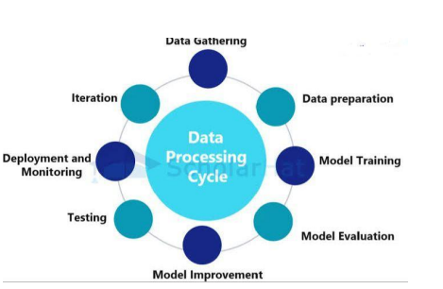

**EXPERIMENTAL SETUP:**

To set up an experiment for a feedback system for online food using a Kaggle dataset, you'll need to follow these steps:

1. Dataset Selection: Choose an appropriate Kaggle dataset that contains relevant information for your feedback system. Look for datasets that include data on customer orders, reviews, ratings, demographics, and any other factors you want to consider in your feedback analysis.
2. Data Preprocessing: Preprocess the dataset to clean and format the data. This may involve handling missing values, removing duplicates, standardizing data types, and performing any necessary feature engineering to extract meaningful insights.
3. Feedback System Design: Design the feedback system architecture, including how feedback will be collected from customers, stored, and analyzed. Determine the metrics and KPIs you'll use to measure customer satisfaction and the effectiveness of the feedback system.
4. Baseline Establishment: Before implementing any changes or interventions based on feedback, establish a baseline performance metric for the online food platform. This could include metrics like average order frequency, customer retention rate, or average rating.
5. Feedback Integration: Integrate mechanisms for collecting feedback into the online food platform. This could involve adding review forms, star ratings, or feedback surveys at various touchpoints in the customer journey.
6. Data Collection: Collect feedback data from customers using the implemented mechanisms. Ensure that the data is stored securely and can be easily analyzed.
7. Visualization and Analysis: Utilize visualization techniques such as heatmaps, charts, and graphs to analyze feedback data and identify patterns or trends. This step may involve using tools like Python libraries (e.g., matplotlib, seaborn) or business intelligence platforms.
8. Experimentation: Implement changes or improvements to the online food platform based on the insights gained from feedback analysis. This could involve menu adjustments, delivery process optimizations, or customer service enhancements.
9. Evaluation: Measure the impact of the implemented changes on key performance metrics. Compare the post-feedback system performance with the baseline established earlier to assess the effectiveness of the feedback system in improving customer satisfaction and business outcomes.
10. Iterative Improvement: Continuously iterate on the feedback system based on insights gained from ongoing data analysis and experimentation. Regularly monitor feedback metrics and make adjustments as necessary to ensure the online food platform remains responsive to customer needs and preferences.
11. Documentation and Reporting: Document the experimental setup, including the dataset used, preprocessing steps, feedback system design, experimental methodology, and results. Report findings and recommendations for future iterations or improvements to stakeholders or relevant parties.

**EVALUATION METRICS:**

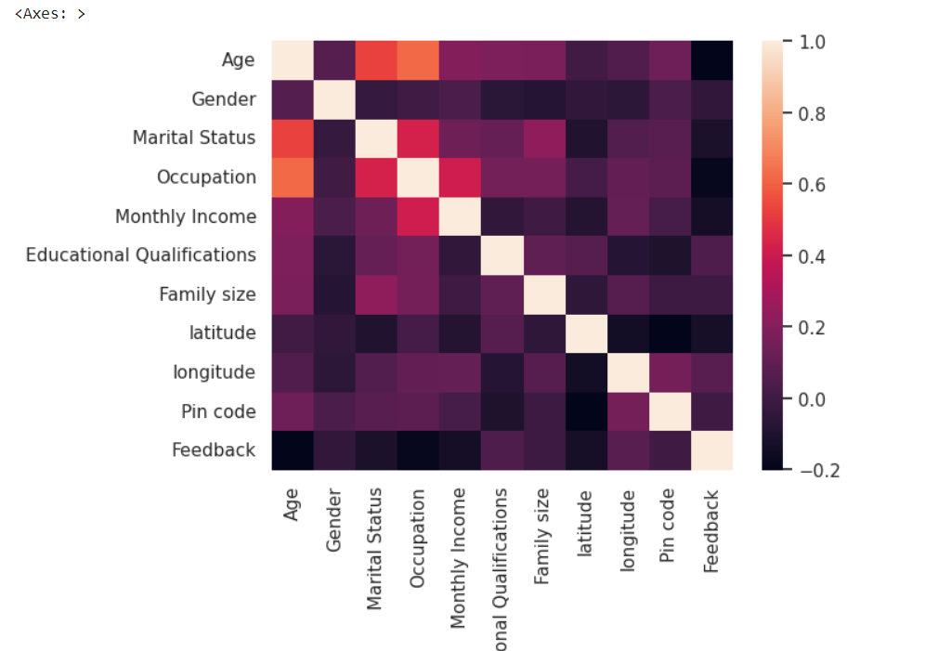

**RESULTS :**



**PIE CHART**

This code segment creates a pie chart using the Plotly library to visualize the distribution of monthly income among customers who make repeat purchases on an online food platform. It starts by extracting the count of occurrences for each unique monthly income value from the "buying_again_data" DataFrame. Then, it prepares the labels and corresponding counts for the pie chart. Next, it defines the colors for the chart slices. After initializing the figure with the pie chart data, it updates the layout with a title. Additionally, it customizes hover information, text display, and marker properties. Finally, it displays the generated pie chart.



**HEAT MAP**

The code `sns.palplot(sns.color_palette("hls",8))` utilizes the seaborn library to display a color palette generated using the "hls" color space, containing 8 distinct colors. The `sns.color_palette()` function generates a color palette based on the specified color space and the number of desired colors. In this case, "hls" stands for hue, lightness, and saturation, which represents a cylindrical color space. The number 8 indicates the desired number of colors in the palette.

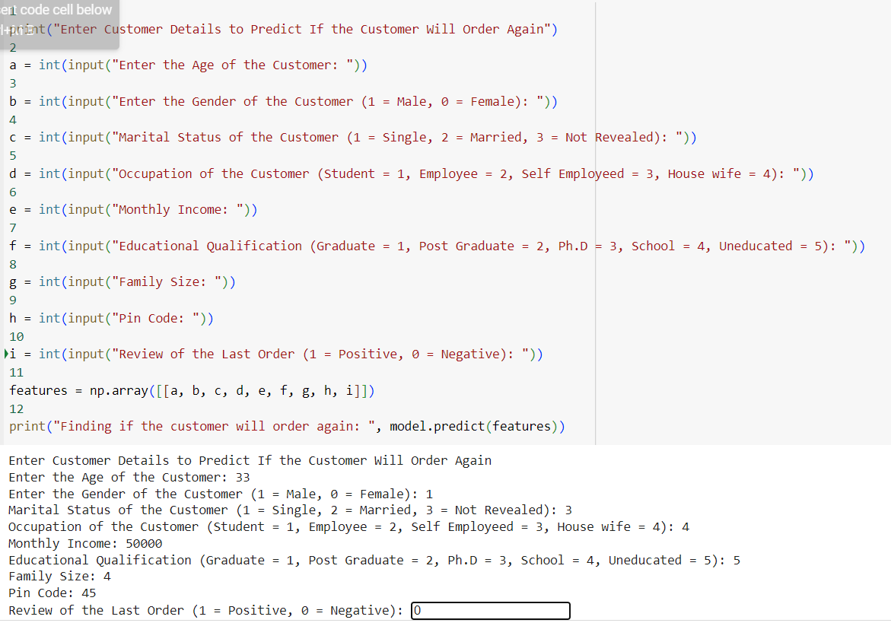

This Python script prompts users to input various details about a customer, such as age, gender, marital status, occupation, monthly income, educational qualification, family size, pin code, and the review of the last order. These inputs are stored in variables. Then, it constructs a numpy array containing these features. Finally, it utilizes a machine learning model (named 'model') to predict whether the customer will order again based on these features and prints the prediction result. This script essentially creates a user interface for predicting customer behavior using a trained model.

**CONCLUSION:**

In conclusion, the incorporation of a feedback system enhanced with visualization and heatmap datasets sourced from platforms like Kaggle offers profound advantages for online food services. By harnessing these datasets, food platforms can gain deeper insights into customer preferences, trends, and pain points, ultimately driving strategic decisions and operational improvements.

The utilization of visualizations such as graphs, charts, and heatmaps enables stakeholders to easily interpret complex data, identify patterns, and prioritize areas for enhancement. Heatmaps, specifically, provide a dynamic and intuitive representation of feedback data, highlighting areas of high activity or dissatisfaction, thus guiding targeted interventions and resource allocation.

Through the integration of these tools, online food platforms can foster a culture of continuous improvement, responding swiftly to customer feedback and market demands. This iterative approach not only enhances customer satisfaction and loyalty but also enables platforms to stay competitive in a rapidly evolving industry landscape.

In essence, leveraging visualization and heatmap datasets from sources like Kaggle empowers online food platforms to make data-driven decisions, optimize operations, and deliver exceptional culinary experiences that resonate with their customer base. This strategic use of data not only drives business success but also ensures the long-term sustainability and growth of the platform in a competitive marketplace.